**Practical No.5**

**Title**: Develop JavaScript to implements Strings.

**Q1] Write a program to perform all the string operations.**

**CODE:**

<html>

<head><h1><b><i>Implemention of strings</i></b></h1>

<title>String</title></head>

<body>

<script>

var string1="Hello my name is Siddhesh. ";

var string2="I am studing in Sandip Polytechnic.";

var string3=new String("Use of the string methods.");

document.write("<h3>1.Use of concat() method: </h3>"+string1.concat(string2));

document.write("<h3>2.Use of charAt() method: </h3>"+string1.charAt(17));

document.write("<h3>3.Use of charCodeAtAt() method: </h3>"+string1.charCodeAt(4));

document.write("<h3>4.Use of indexOf() method: </h3>"+string2.indexOf('a'));

document.write("<h3>5.Use of lastIndexOf() method: </h3>"+string1.lastIndexOf("BISMA"));

document.write("<h3>6.Use of search() method: </h3>"+string3.search("methods"));

document.write("<h3>7.Use of match() method: </h3>"+string3.match("string"));

document.write("<h3>8.Use of replace() method: </h3>"+string2.replace("KKW","K.K.Wagh"));

document.write("<h3>9.Use of substring() method: </h3>"+string2.substring(5,13));

document.write("<h3>10.Use of substr() method: </h3>"+string2.substr(5,13));

document.write("<h3>11.Use of slice() method: </h3>"+string2.slice(5,13));

document.write("<h3>12.Use of toLower() method: </h3>"+string3.toLowerCase());

document.write("<h3>13.Use of toUpper() method: </h3>"+string1.toUpperCase());

document.write("<h3>14.Use of split() method: </h3>"+string1.split(' '));

</script>

</body>

</html>

**OUTPUT:**

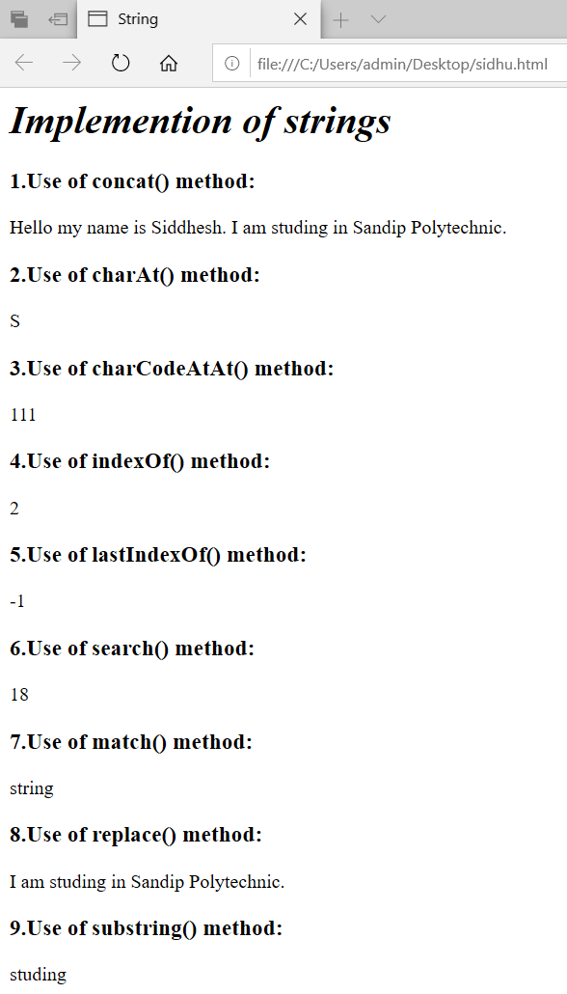

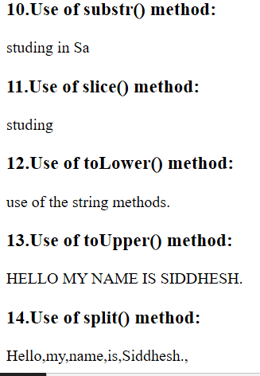

**Q2] Write a program that checks whether a passed string is palindrome or not.**

**CODE:**

<html>

<head><h1>**Pallindrome**</h1>

<title>Final Practical 5_2</title>

</head>

<body>

<input type="text" id="string">Enter a string</input>

<button onclick="pallindrome()">pallindrome</button>

<script>

function pallindrome()

{

var string=document.getElementById("string").value;

var len=string.length;

var copy=string.slice();

var string2=string.split('').reverse().join('');

var no=string.localeCompare(string2);

if(no==0)

{

document.write("<h2>String is pallindrome</h2>");

}

else

{

document.write("<h2>String is not pallindrome</h2>");

}

}

</script>

</body>

</html>

**OUTPUT:**

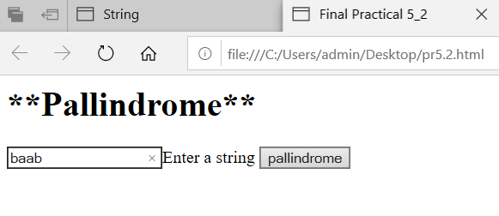

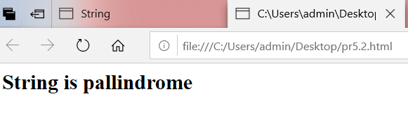

**Q3] Write a program to insert a string within a string at a particular position.**

**CODE:**

<html>

<head><h1>**PRACTICAL 5**</h1>

<title>Final Practical 5_3</title>

</head>

<body>

<script>

var string='Good Morning EVERYBODY';

var string2='hello';

var position=13;

var output=[string.slice(0,position),string2,string.slice(position)].join('');

document.write(output);

</script>

</body>

</html>

**OUTPUT:**

